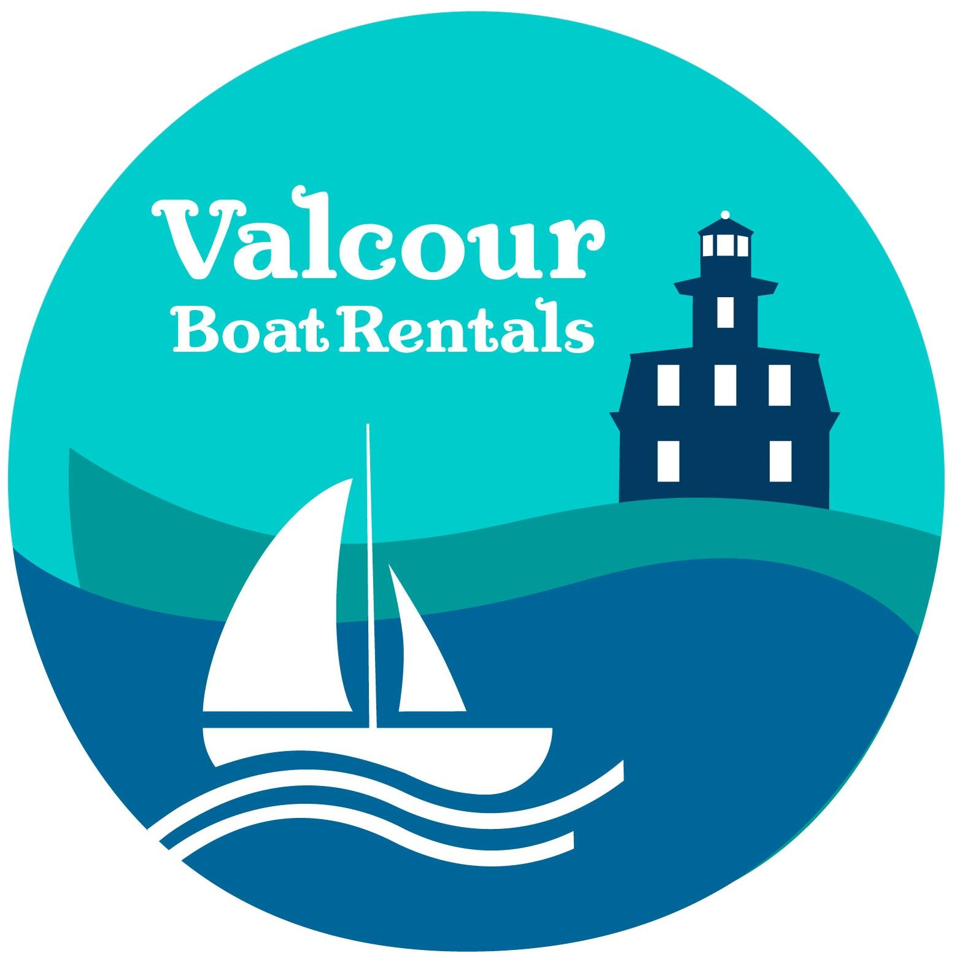

Boat Rental Agreement

You must first read and accept the following terms before proceeding.

Modern Equipment- Daily or Weekly Rentals

- You are solely responsible for all damage and loss due to wind, storm, theft, etc.

- All reservations will require a deposit be made in advance. This deposit can be made in the form of a check, Direct Deposit, or credit card (MasterCard/VISA/AMEX) and is NON-REFUNDABLE without a 14 day notice.

- Reservations will be accepted via phone or email. If you must cancel your reservation, your deposit will only be refunded to you if you give us at least 14 days notice before your arrival.

- A security deposit will be required on all boats. Upon return of the boat, an inspection will be made and the deposit will be returned MINUS the repair cost of any damage done to the boat and/or motor and MINUS the NEW REPLACEMENT VALUES OF ANY LOST EQUIPMENT. You must return the boat in the same condition it was in when rented or pay for the difference.

- All security deposits and rental fees are to be paid in full before the boat leaves the dock. Since the DEPOSIT IS A DOWN PAYMENT ONLY on major damage, we rent to FINANCIALLY RESPONSIBLE ADULTS ONLY. RENTER IS RESPONSIBLE FOR DAMAGES ABOVE & BEYOND THE DAMAGE DEPOSIT.

- The propeller will be inspected both when you leave and when you return with the boat. ANY DAMAGE WHATSOEVER WILL RESULT IN THE PURCHASE OF A NEW PROPELLER. SEVERE PROPELLER DAMAGE will result in the LOSS OF THE ENTIRE DEPOSIT to cover internal hidden damage.

- INSURANCE IS NOT OFFERED. YOU ARE RESPONSIBLE for all damage up to the replacement value of the boat, motor, and for all accidents and injury to any person or property. Since boating has many inherent dangers extreme care must be taken in the operation and use of our equipment.

- NO REFUNDS will be made due to poor weather or if the boat is brought back ahead of schedule.

- ALL FUEL IS EXTRA in addition to the rental and deposit fee. Tanks will be full when you depart and you are required to fill the tank upon arrival.

- Breakdowns must be reported within the hour by calling the “Emergency List” located on the boat.

- If the boat is a multi-day rental and comes in after hours, the operator is responsible for tying up the boat. Any damage to the rental boat or boats nearby that occurs due to incorrect tying procedures is the operator’s responsibility. Renter is responsible for all damages during the period of entire rental, this includes damages at our docks while under your agreement.

- By contract you are TOTALLY RESPONSIBLE for any damage to the rental boat. Lessee agrees and understands that the vessel is to be left clean, undamaged, and in the same condition as the start of their reservation. Valcour Boat Rentals LLC reserves the right to charge for cleaning and/or repairs.

- A credit card must be on file at the time of departure. The card will be used to cover any additional charges associated with damage to the rental and gas charges (If not returned at the correct level). By signing this agreement I authorize Valcour Boat Rentals to charge my card for damages. I understand and have been made aware that I am renting this boat with no renters insurance from Valcour Boat Rentals LLC.

- Lessee hear by authorizes Valcour Boat Rentals LLC to charge the Lessee’s credit or debit card for any damages done to the vessel during the lessee’s reservation.

I have read and agree to the boat rental agreement:

Customer Name ________________________________________ Date _________

Customer Signature _____________________________________ Date __________

